Abstract
An algorithm was created for a political campaign in Fall 2014 to help find the best way to take voter data and use it to predict the likelihood of voter support. Survey workers collected individual surveys from potential voters in the 2014 Kansas Second House District race. Surveys were matched against data provided by the party in an attempt to predict candidate support.
This thesis compares different classifying methods that can narrow down relevant independent variables to the algorithm developed in part with input from the client, known as the Best Subset with Validation Algorithm (or BeSiVa). BeSiVa focuses on choosing independent variables based on prediction rates in a separated pseudo-test set. With a percent correctly predicted comparable to the other classifiers, BeSiVa dealt with missing data, created more interpretable models with fewer predictors, and predicted support with a similar accuracy to other methods on bootstrapped subsets of campaign data.

Background and Statement of the Problem
In the summer of 2013, I was hired as an account executive at Activate LLC, a company that focuses on the sale and support of phone surveying software and conducting surveys. Activate's clients include unions and non-profit organizations, but the majority of the company's purchases come from political campaigns. I also developed analytical methods for the accurate description of potential voter preferences as part of my duties as an account executive. These methods focused on the analysis of survey data.
When analyzing the survey data provided by campaigns, ordinary least squares and generalized linear models functioned, but they had problems that interfered with modeling support. While these conventional regression techniques made it possible to estimate likelihood of voter support for a particular candidate or ballot initiative, they proved unsatisfactory during analysis due to the time and consideration needed for selecting relevant independent variables, variables that predicted support in different environments, for different initiatives, and individual candidates. Most problematically, the regression analyses never provided a satisfying answer to what I still see as one of the most essential problems with the data. With the large number of independent variables, logistic regression falls short when looking for relevant independent variables from a collection with a quantity greater than an individual modeler could consider and sift through.
We face a problem of variable selection when working with a dataset that includes columns representing many potential independent variables and determining which variables should be included in a particular model. The variables whose inclusion campaign managers demanded were rarely sufficient for the accurate description of voter preferences. Exacerbating the problem of selection, campaigns often provided hundreds of columns of data on surveyed voters, and the quantity of information provided made sorting through the variables to find those most capable of predicting voter support difficult. As time went on, my employer described my work as 'reinventing the wheel' for each modeling project performed, due to my need to consider the relevant variables of different data sets. While certain variables did come up frequently, there was no guarantee that the selections which effectively defined voter support in a municipal race in New York or a ballot initiative in Missouri could serve to describe a race for the House of Representatives in Kansas, and the question of finding information that predicted voter support in the data provided by state and local parties was of crucial importance.
The problem of finding relevant variables for predictive modeling came to a head in the summer of 2014, when I was working on a way of accurately describing the voting universe for Margie Wakefield's campaign for Kansas' Second House district. Collecting data for the Wakefield campaign, the company conducted a survey on voters across Kansas' second district. I had some input on the survey's design. After the phone interviews, the Kansas Democratic party provided data on the individuals surveyed. The data provided included 313 columns, many of which were likely irrelevant, but the party promised a dataset of variables found to be relevant, which could be matched to a dataset and used to predict support of voters in Kansas' Second district. The information available to the campaign dataset included multiple spreadsheets of data on the surveyed population, with 313 variables between the 1,540 respondents.
With the goal of creating a method to parse, and select independent variables for a model that would designate who the campaign would try to reach and turn out, I created the BeSivA algorithm. I discuss the algorithm below and compare it to other methods of classifying observations which I have learned about since the campaign ended. I based the algorithm on a consideration of the demands made by the campaign manager and my own personal desire for an algorithm that selects by an criterion that differs from those that focus on the training data, or data used to create the model. When compared to other developed methods, BeSiVa performs a more interpretable fit on the data it uses compared to the other classifiers, and has a performance comparable to penalized regressions with when comparing on a set of validation data. It also pares down the independent variables and runs with data that contains missing values. For these reasons, the BeSiVa algorithm serves alongside other methods of predicting a dependent variable, serving as a tool that campaigns may use to better understand the universe of voters they are trying to reach.
While finding the right instrument to create a predictive model is a classic problem in the field of 'big data', and is a problem with this in this case, it is also necessary to find relevant variables in provided voter data. In addition to a campaign's scope frequently prohibiting the use of an accurate surveying instrument on a majority of the electorate, the question of how to use preexisting voter data becomes salient when analyzing a small survey for such a campaign. The Kansas Democratic Party had access to a large database of voter information, dealt out based on necessity to political campaigns in the state, including information on whether individuals voted in specific races, local census data including population density and median income, and voters' consumer choices such as whether an individual is likely to rent to own furniture or has a pet in the house. While generous with the data for the individuals used, the party was less interested in providing the same information for the entire voter universe, preferring to keep the number of independent variables provided for the entire universe low. Thus, the client would prefer to use a model that keeps the number of relevant independent variables low, as it is cheaper in terms of time and energy to collect less data from the party. In attempting to provide campaigns with useful information, however, the party can offer an expansive collection of data to consider.
The data available to campaigns is expansive, but getting such a large variable collection comes with drawbacks. As a majority of these variables are irrelevant or likely to be collinear, with some offering fewer contributions to a model than other predictive independent variables, the question of parsing the party's collection of data to find independent variables that relate to voter support remains challenging. In addition, this challenge is exacerbated by the understanding that some variables are highly likely to be relevant or preferred by campaign officials, based on preexisting understandings of how voters differ within the electorate, such as political party, geographical population distribution such as county, and whether a voter turned out in elections akin to the modeled one. Thus, any attempt to consider voter support quantitatively demands a means of building instruments designed to predict voter interest in candidate positions, as well as to sift through the vast quantity of information collected by the party backing the campaign to determine voter support for a candidate based on specific messaging.

Surveying Methodology
The dependent variable was a response to a survey question, collected in the 2014 House race in Kansas' Second District by survey workers associated with political campaign of Margie Wakefield, the Democratic candidate. The survey was collected through the use of Activate LLC's predictive and preview dialing software, for cell and landline phones. Due to the illegality of using predictive dialing software to contact cell phone records, survey workers used preview dialing to collect surveys from voters who could only be reached at their cell phones.

The Dependent Variable
The campaign collected survey data that included questions to addresss constituents' opinions on categorical issue positions, which were used to tailor messaging, as well as to collect more detailed survey data used which served as the dependent variable. The survey consisted of six questions, designed to help tailor messaging and reveal a voter's overall affect for a candidate. The introductory survey question focused on issues and messaging relevant to the campaign, and this question changed between phases of the survey. The question was intended as a way of warming up the voter to taking the survey and was not used in the modeling. The survey workers alos asked three questions to determine voter's preference between the candidates' issue positions. For these questions, the volunteer conducting the survey first read two messages, both designed by the campaign, and then asked the voter to choose between them on a scale of one to ten, with one representing complete support of the opposition and one representing the campaign's interpretation of the opponent's position, and a sample issue question can be read in the appendix. Each of the messages followed the same format as the sample question, including brief descriptions of the position held by the candidate and their opponent, which was how the campaign might describe their opponent's position in messaging and debates. These questions were interspersed with the primary focus of modeling, which the campaign referred to as identification questions.
The primary goal of the survey was determining overall voter support for the candidate. Survey workers asked two about candidate support(one at the start, and one at end of the survey). These two questions named the candidates, their respective parties, and asked the voters to choose which they would be more likely to support on a scale from one to ten in the 2014 Kansas Second District House Race (clarify note). These questions required voters to identify with the individual candidates. Selecting one meant the voter agreed or identified with Lynn Jenkins, the opposing candidate, and ten meant they agreed or identified with Margie Wakefield. Voter identification questions were placed deliberately. One identification question appeared immediately after the messaging question, while the other was the final question asked in the survey. This final question, which can also be seen in the appendix, served as the primary focus of the modeling for the campaign.
While I had persuaded the client that the underlying relationship needed a fine distinction to capture, the usage of the 1-10 scale is the next problem to consider. Although survey workers had been collecting the data in values from one to ten, the histogram of the data suggested that the 1-10 division was either too fine a distinction to capture underlying relationships or that the actual relationship was truncated, limiting the electorate when their actual beliefs might be more nuanced. Focusing on the histogram of the dependent variable which can be seen below in figure 3, the pattern is almost trimodal, primarily concentrated on the edges of the distribution but with a smaller peak in the center. This shaping indicates a severe polarization in the electorate, with 65.9% of surveyed voters supporting either of the candidates wholeheartedly and 34.1% in the center in some capacity (with 10.1% choosing 5, the undecided option). While some regression options might be chosen, the client's concern with support led to a different conclusion, leading to the dichotomization of the dependent variable.

Figure 3: A histogram created in R of voter responses to the final identification question as a density estimate. Note the trimodal nature of the data, which lead to the decision to recode the dependent variable as dichotomous .
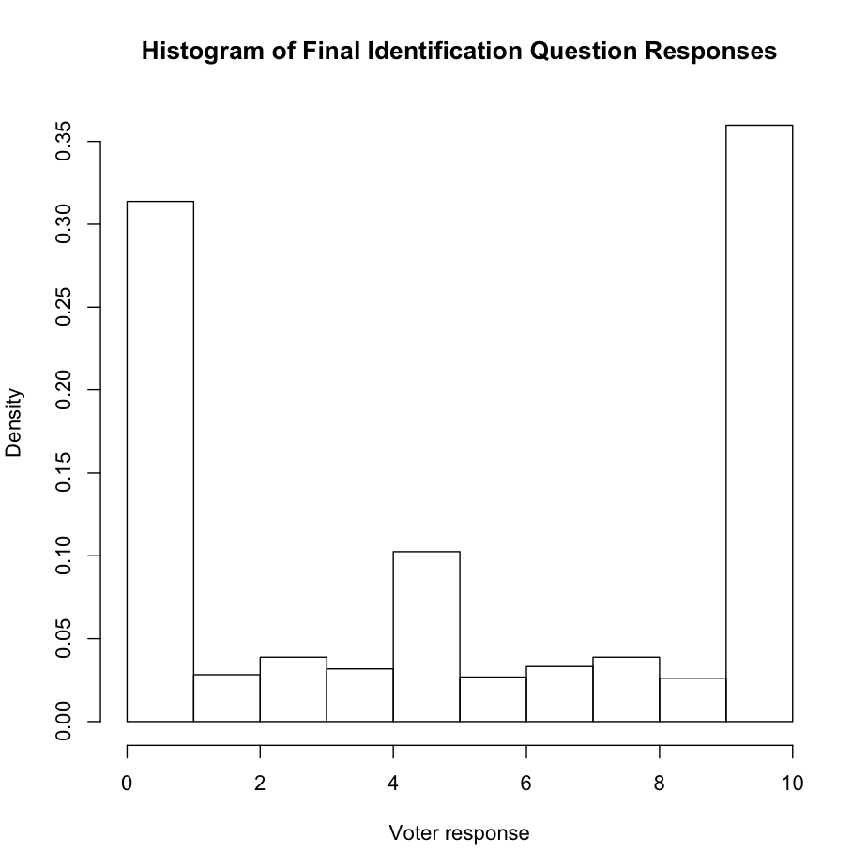
The scaling was reconsidered based on the preference of the client, whose main concern was the likelihood of voter support. Looking at whether the voters supported Margie Wakefield on the position articulated during the survey, and the data was recoded as a dichotomous variable. While the scaling may have truncated voters' beliefs, the options most appealing to the client led me to the conclusion that the dichotomization was preferable. Survey workers had been coached during the survey that any voter response of five or six would be considered undecided, but the recoding reflected difficulty among survey workers (who were all campaign volunteers) in recalling that as part of the dichotomization of the numeric responses. Thus any value below 6 was recoded as a zero, indicating that the person did not support Margie Wakefield on the issue or identification question, and any value above six was coded as 1, a response that supported Margie Wakefield and would hopefully lead to support in the polls. Using this dichotomization with a logistic regressions, the results rose above the mode value percentage, but despite its ability to predict dichotomized dependent variables (R Core Team 2014) the base glm regression in R did not allow for an appropriate consideration of the independent variables and how the large quantity of provided data could be included in the development of a model of voter support.
When developing the support model, a few preferences of the client came into play when selecting the instrument used. The client's desired a model that predicted the support of individual voters based on the survey data collected, was highly interpretable, and had a smaller number of independent variables due to cost of collection. While the primary goal, predicting voter support, was non-negotiable, interpretability and number of independent variables, meaning that a model could have more independent variables if it improved interpretability or made better predictions. As the number of independent variables.

An Overview of the Independent Variables
The independent variables came from a preexisting database provided by the Kansas Democratic Party. This data included available census data such as ethnicity, housing information, and levels of education. In addition, the party collected data on individual voting records, and made available whether someone was a voter in any previous election up to 1996. The party also provided independent variables that included consumer data. With the large quantity of data, however, came a problem that needed addressing. Even after the ad hoc removal of variables that were redundant, mostly missing, or of low variance, 184 columns independent variables remained, with each holding potential predictive power. There are several reasons why conventional regression techniques may cause problems with 184 independent variables as possible candidates for inclusion in a model. Placing all independent variables into a single regression would make paring down the data difficult due to the certainty of multicollinearity. In addition most of the independent variables had missing data, eliminating 1,355 observations, or 87% of the rows, from consideration. While the number of observations dropped to 185, meaning that all independent variable data could be included in a regression, ignoring the majority of the observations and data due to missing values seemed unconscionable due to the potential usefulness of the included information in terms of modeling and prediction. Kuhn and Johnson (2013) suggested the use of cross-validation for comparing across different types of models, but had no suggestions for dealing with an excess of independent variables outside of adding them all into the model, an undesirable result due to the large quantity of missing data among independent variables.

Preexisting Options
The glmnet package, created by Friedman, Hastie, and Tibshirani (2010) gives users of R the ability to perform penalized regression analysis, substituting the unbiased regression used in the default form of generalized linear modeling for penalized regressions. A penalized regression decreases model variance by adding bias to each estimate in the form of a penalty. Using the form of OLS as an example, regressions created by minimizing RSS in equation 1,
(1)
where
(2)
choose estimates of β in equation 2 to minimize the difference between the dependent variable y and the value of f (x_{i}). Instead of letting the coefficients vary freely, the penalized regressions each add a penalty to equation 1, changing it so that the minimization takes into account the size of the predicted coefficients using a penalty function multiplied by a tuning parameter, λ, as seen in equation 3
(3)
By adding this penalty, the coefficient estimates are constrained, shrinking them to zero with sufficiently large penalties. The ability to shrink coefficient estimates to zero, invalidating the inclusion of unrelated independent variables in a model made the use of the lasso and elastic net penalized regressions viable alternatives to the method created.
The R package glmnet extends penalized regressions for gaussian, logistic, and other link functions used by the glm command, allowing for options within these models including shrinkage. Of the three penalizations enabled by the glmnet package, only two of the penalties guarantee shrinkage, the lasso and the elastic net (Hastie et al. 2009). The lasso adds a penalization to the equation to minimze based on the absolute value of the coefficients' sizes, as seen in equation 4
(4)
which drives irrelevant coefficient estimates to zero for a large enough tuning parameter (James et al. 2013). The elastic net adds a different penalty to the value to be minimized. Its penalty is a the sum of the lasso and ridge regression penalties and is displayed in equation 5
(5)
mirroring the form of the penalty calculated in glmnet (Friedman et al. 2010). In addition to the λ parameter, the glmnet package has a version of the elastic net that includes a second tuning parameter, α. α falls between 0 and 1, and varies the contribution of each penalty to the final coefficient value. When each penalty is chosen to minimize the RSS using cross-validation or bootstrapping, the elastic net's dual penalties can outperform the lasso for prediction while still allowing for coefficient shrinkage (Zou and Hastie 2005).
In R's base statistics package, the regression commands use a draconian measure to deal with missing values, but do so to ensure greater versatility when data is missing. The base commands use listwise deletion to deal with missing options (R Core Team 2014), which eliminates rows with missing data from the regression. The glmnet package is further limited in this respect, refusing to run any regression unless the input does not include missing data, requiring a separate step for listwise deletion or imputation (James et al 2013). Despite the diverse regression options in glmnet, the package is limited due to its dependence on imputed data, meaning that the same data with missing values will provide different results due to the requirement of imputation or listwise deletion. While the use of a single imputed data set guarantees the same result for each use of the regression, the usefulness of methods that cannot function unless input data has no missing values or is imputed remains questionable, especially for large datasets.
In addition to the penalized regressions used by the glmnet package, other methods of predicting a binary dichotomous dependent variable could be used for the classification of voter support, but fail when presented with missing data. One method recommended for classification, the randomForest package's classification trees allows the software to categorize an observation while creating a highly regression tree (Liaw, A. and M. Wiener 2002). The randomForest algorithm classifies observations based on choices it makes to determine first which divisions in a set of data predict a dependent variable classification, and then classifying the dependent variable based on the designations the random forest algorithm decided were relevant (Hastie et al. 2009). This method then allows for the prediction of whether someone supports a candidate, but its use is also problematic due to its behavior when provided data with missing values.
The randomForest package's main command appeared to allow for missing data, containing an option known as na.action that should allow for listwise deletion (Liaw, A. and M. Wiener 2002), but even when the function to use listwise deletion on the data was designated in the argument, the random forest command refused to run, instead saying 'NA not permitted in predictors'. The debate over what to do with missing values includes multiple options, such as listwise deletion, preprocessing the data through imputation, and the categorization of missing values separately, so that the forest can catalogue these values separately and find out more about their potential role in predicting the dependent variable (Hastie et al. 2009), but the randomForest is unable to run properly unless the data has no missing values, making it challenging to use consistently with an unimputed dataset. Therefore, although the random forest method has the potential to run with the dataset provided, the function and method fail to include options to account for the the likelihood that data provided is incomplete. Due to this absolute requirement for a complete set of data, the random forest technique would have served poorly as a classifier for the data provided, and other methods needed consideration.
The 'best off the shelf classifier', the Adaboost.M1 algorithm, serves as a means of dividing observations by classification, but issues with the algorithm made implementation for the campaign's data undesirable. To make predictions based on a training set, Adaboost.M1 generates an initial classifier for the training set, weighting each observation equally in its consideration. It then reconsiders its predictions, increasing the weights of observations where the classifier failed to correctly classify in its previous attempt. The algorithm then weights each classifier by their success, and adds each of the classifiers together multiplied by their weights to create a final classifying function, which is then used to make predictions (Hastie et al. 2009). While this method appeared to have results similar to the other methods for imputed data, the off the shelf classification was unsuitable for the problem I was trying to solve. Creating the best prediction remains the primary goal of trying these methods, but there is some need for parsimony, as the Kansas Democratic party was unwilling to provide a dataset with all variables for the entire voting population. In addition to using a majority of provided independent variables, the output of Adaboost.M1 is obtuse compared to the penalized regressions, random Forest, and BeSiVa, returning a vector of relative importance that took the variable's Gini index gain and tree weight into consideration when ranking independent variables (Alfaro et al. 2013). The low interpretability and high number of independent variables that Adaboost.M1 requires to make predictions makes it difficult to justify using to classify voter support. In addition, Adaboost.M1 overfits the imputed data dramatically, creating a set of perfect predictions of the training dataset, and making predictions on the test set with a greater error rate than penalized regression. Finally, Adaboost.M1's relationship to missing data differed from the other methods, but still failed to consider the set if dependent variable data was missing. While the algorithm can run if there are missing values in the independent variables, AdaBoost.M1 fails if the dependent variable contains missing values. Thus, despite its reputation, Adaboost.M1 is unsuitable for the final fit, due to its low interpretability, need for the majority of the independent variables considered, overfit on the test set, and some difficulty in dealing with missing data.
While thematically similar to the created algorithm and capable of dealing with missing data, the subset selection and stepwise methods are problematic due to computational and conceptual limitations. In order to create highly interpretable models that do not require the use of imputed data, Best subset selection focuses on building a model with every possible combination of independent variables and choosing the best model from all potential candidates. Best subset selection chooses the best model using a statistical criterion such as adjusted R², the Akaike Information Criterion, the Bayesian Information Criterion, or Mallow's C_{p} to determine which regression best predicts data outside that used for modeling while using only the data that included in the model. While versatile in criterion and types of models used, and guaranteeing the best model for the selected criterion, best subset selection must run 2^{p} models, where p is the number of potential independent variables. This limitation means that best subset selection requires vast computational time for any collection of independent variables greater than 40 (James et al. 2013), and the use of every combination of the 184 independent variables in the data results in 2.45 × 10⁵⁵ different models, making the best-subset selection method unsuitable for this problem due to the inordinate length of time needed for calculation. Avoiding the computational requirements of Best Subset Selection requires the consideration of methods that limit the number of models predicted while still selecting independent variables that best explain the dependent variable outcomes, but these methods remain problematic due to theoretical obstacles to good results.
To approximate the results of best subset selection without its computational limitations, stepwise selection methods run multiple regressions with independent variables chosen by their impact on the fit. Stepwise selection seeks to find the predictors that create the best model by adding or removing predictors depending on whether the forward or backward stepwise method is chosen. With forward stepwise selection, the dependent variable is fit without independent variables, which are added one at a time based on which one best improves the overall fit on the training data. The final number of independent variables is a tuning parameter that must be adjusted based on the same model criterion used in best subset selection, but forward stepwise selection is advantageous for several reasons. As described, forward stepwise selection fits a comparatively small fraction of the models seen, a maximum of 1,7021 for the 184 predictors in the campaign's dataset, making it much more computationally feasible than best subset selection. Forward stepwise selection can always be used, no matter the number of predictors (Hastie et al. 2009), making it superior to backward stepwise selection in this regard. Despite creating the same number of models, backwards stepwise selection can only be run if there are fewer independent variables than there are observations. If this condition is met, however, backward stepwise selection guarantees the consideration of all independent variables, placing them into a regression and removing one when the independent variable fits a specific statistical criterion such as highest p-value, allowing backward subset selection to find the single best model among those that can be created, using the same criteria as best subset selection (James et al. 2013).
Despite their ability to wander unaided through independent variables to select models that fit the data well, the stepwise and best subset regressions have faced criticism for questionable statistical properties. On a frequently referenced webpage in the STATA support message boards, biostatician Frank Harrell discusses some of these problems, describing how stepwise regression R² values are biased to be high, due to the the method's proclivity for adding variables even they add very little information or prove theoretically irrelevant. With the output, Harrell continues by describing how F and Chi square tests next to each variable do not have the claimed distribution. The confidence intervals and predicted values are falsely displayed as narrow, while the selection method's p values are difficult to fix. The methods are also described to have severe issues when collinearity is a factor. Harrell also describes how the issues raised are not helped by altering facets of the problem, such as adding data or working from best subset rather than stepwise methods, and condemns the methods by describing stepwise solutions as a substitute for thinking about the problem at hand (1998).

A Description of the BeSiVa Algorithm
Independent of the methods already described, I created the BeSiVa algorithm to determine the likely support of voters in a race for Kansas' Second District, using data from a survey instrument collected in the state and data provided by the state party. The survey instrument and the party data had been matched for each individual, and the algorithm was implemented after preprocessing. After a number of categorical variables were eliminated, as well as irrelevant identifying information like names and addresses, the dependent variables were changed from their original 1-10 scale to a dichotomous support-nonsupport variable, with 6 and above indicating support, and 5 and below indicating a lack of support as described by those who were involved in collecting the survey data. Ages were categorized according to the campaign manager's preference, and binary variables were created to describe those who had only voted in the last two non-midterm elections, and those who had voted in the 2010 midterm. All voting history data besides the two binary variables was treated as irrelevant, and not allowed into the final model. With this preprocessing, the data was organized in the code to finish preparing it for use by the algorithm.
Once the data was preprocessed, some subsetting occurred as preparation for using the algorithm. The data was separated into two parts: training and pseudo-test data, so named because unlike test data, the pseudo-test data is incorporated into the algorithm as part of selecting independent variables. The pseudo-test data was a randomly selected set of records constituting 10% of the survey results, with the remaining 90% serving as the training data. Then, a set of columns identified as redundant, of low variance, or irrelevant (including some personal information and an unconsidered categorical pre-test question), were dropped from the data that would serve as potential independent variables. A set of independent variables were identified as always included variables, or AIVs, which would always be included in any created models, due to potential theoretical relevance and the demands of the campaign manager. This combination of creating a validation set and designating AIVs shaped how the algorithm used the data set when operating.
After the independent variables were selected and organized, the algorithm could proceed. All models, regressed using the training data, were built from the glm function in R, featuring a logistic regression via the family argument (R Core Team 2014). The dependent variable was first modeled against the AIVs. Once this initial model had been created, it was used to analyze BeSivA's pseudo-test set, making predictions about the likelihood of support in the pseudo-test data. These predictions were then compared to the pseudo-test set's dependent variable data, calculating the percent of correct predictions (hereafter the PCP). Due to logistic regression's ability to predict probabilities between 0 and 1, the PCP is defined as the percent of predictions less than 0.50 for responses of zero and predictions greater than or equal to 0.50 for responses of 1, divided by number of responses. The AIVs and their PCP were stored, and the first loop created individual models for each potential independent variable and the AIVs. The algorithm then calculated the PCP of each of these new models. If a model's calculated PCP was greater than the original model, all included independent variables and the new PCP were stored. This was repeated for all remaining independent variables, and the independent variable whose model featured the highest PCP was added to the AIVs, allowing it to remain for the second loop, which controlled the number of times independent variables could be added to the AIVs. This second loop contained ten iterations, but its length was arbitrary, as the addition of independent variables eventually failed to improve the PCP, and after an iteration of the second loop without PCP improvement, the algorithm ended. Thus, by allowing each independent variable to become part of the model, the algorithm allowed both for the selection of the most appropriate independent variables among a large set such as the one provided to the campaign.

Limitations of BeSiVa's initial formulation
Despite its promise in making predictions through the consideration of a pseudo-test set, the initial formulation of BeSiVa is limited due to a number of potential issues arising from the data and the algorithm. These issues arise from the fact that BeSiVa treats every regression as a fresh problem. While the algorithm allows for continuity between selected variables, keeping independent variables that maximize PCP in the model, it also calculates an entirely new regression for each combination of independent variables considered. This formulation of BeSiVa provides no continuity between predictor coefficients, allowing their values to fall freely. While this means that coefficient values are consistent with a generalized linear model, guaranteeing that the results are easily interpretable, the lack of continuity is problematic both for computational and algorithmic reasons. When using the algorithm, the free assignment of variables proves computationally expensive, slowing the algorithm unnecessarily. Conceptually, there is a preference for continuity among coefficients, as the results demonstrably affect the overall fit created by the algorithm.
Giving the algorithm free choice of coefficient values proves computationally expensive, but the conceptual aspect of treating each regression as a new problem bears similarities to the stepwise selection methods. Despite its independent development, BeSiVa has similar problems to the stepwise and best subset selection methods, especially issues with multicollinearity. A value may have no theoretical relationship with the dependent variable but can predict the dependent variable due to collinearity with an independent variable. If there is a relationship between two independent variables, one that relates both theoretically and has a statistically significant relationship with the dependent variable and one that does not, their inclusion creates a situation where a variable that has no theoretical basis gets included in the model. This issue with collinearity causes ordering to be an issue for the algorithm, suggesting that if a variable that predicts the dependent variable well due to correlation with another theoretically viable independent variables, then the irrelevant variable may take over some of its viable correlate's value, and possibly prevent the correct variable from appearing in the model. This however, would require perfect correlation, as any improvement in the PCP is sufficient to include a variable in the final model. Like other subset selection methods, BeSiVa never substitutes for thinking about the problem, an issue Harrell raises with stepwise and subset selection methods (1998), but it can allow a researcher to input a data build models which can make predictions on a new dataset. Using BeSiVa to enhance theory, however, runs afoul of its original purpose, prediction of these responses given a small number of points with the included response.
When looking at the the formulation of BeSiVa, a possibility arises that variables are included that do not improve the final model, especially in the AIVs. For instance, when running the data for the Wakefield campaign, the campaign manager demanded a categorization of age that didn't necessarily improve the fit, and I designed an element of the algorithm to mitigate these variables. Included variables that weren't part of the AIV set needed to improve the performance of the designated pseudo-test set, smaller than the training set and specifically separated from training data for test purposes. Despite the potential inclusion of irrelevant variables, even by fiat, BeSiVa mitigates their effects by design, due to the pseudo-test set which allows the algorithm to work around them, providing the best fit of the data based on the pseudo-test PCP.
In addition to the problem of irrelevant included AIVs, the BeSiVa algorithm can run into trouble due to its treatment of missing values and reliance on the way an independent variable interacts with the PCP. While functions like the glmnet fail when introduced to data with missing values and must rely on imputed data (Hastie et al. 2009), BeSiVa handles the values by listwise deletion of included independent variables, due to its use of the glm function in R. BeSiVa is therefore more tolerant of missing values the other methods, but this tolerance represents a low bar, as it still can run into issues due to the lack of a consideration of how listwise deletion can affect data. Suppose the data run through the algorithm included a variable with a high number of missing values, but the remaining values predicted the data very well. BeSiVa would run, but its current incarnation risks using a very small subset of the data if that subset's PCP is higher than any other value. In practice, the missing data wasn't a major factor due to preprocessing and the use of imputed data during analysis, but it presents a potential effect on larger datasets with greater counts of missing variables. This problem, however, must be considered in context. Without exception, all comparable algorithms require parts of the data or the entire set to be complete, and all comparisons have attempted to meet this requirement through the mice package's imputation by chained equations (van Buuren and Groothius-Oudshoorn 2011), meaning that while a column of missing data can be problematic for the algorithm, its handling of missing values is still an improvement on the other methods used for comparison.

Comparison and Results
To determine the quality of BeSiVa's fitting, the method was compared against several others using a bootstrapping iterative process and imputed data, so the every method could function. The program split the imputed data using a random seed to determine the test, pseudo-test, and training sets, and calculated the final percent correctly predicted on the test set by BeSiVa, the elastic net and lasso penalized regression methods, the Adaboost.M1 algorithm, and the random forest. Gathering 50 PCP values on the bootstrapped test sets from each method and storing them in a matrix, I then took the values of the PCPs and converted them into a single column of data, regressing the models' numeric PCPs against a categorical variable containing the name of the regression used for each PCP to determine whether BeSiVa's performance differed from the other methods. If BeSiVa could make predictions with the same quality as the other methods, then there should be no statistically significant difference between BeSiVa and the other methods. Thus, a Null Hypothesis that the average of all values were the same is considered using ANOVA to make the comparison.
The results of the analysis of variance for the bootstrapped PCPS and the linear regression used to create it appears in Tables 1 and 2 in the appendix, demonstrating the performance of BeSiVa compared the other methods. In Table 1, the ANOVA data is displayed, showing that there is a difference in population means, demonstrated by the statistically significant value of the F test. Table 2, however, demonstrates that while this is the case, it stems from the underperformance of the Adaboost.M1, and random forest algorithms. In table 2, the Adaboost.M1 and random forest percentages both have a statistically significant but smaller estimate than the BeSiVa algorithm, Elastic Net, and Lasso regressions, indicating that the BeSiVa algorithm outperforms Adaboost.M1 and random forest on the data with 95% confidence. The elastic net and lasso techniques also have comparable coefficients, and while all of the p values approach statistical significance, Figure 4 shows that their mean falls below that of BeSiVa, suggesting that the overall performance of the penalized regressions and BeSiVa are comparable, but the Adaboost.M1 and random forest algorithms are not. Thus, using the same data, the BeSiVa algorithm creates a set of predictions on the test set that when compared to other methods using bootstrapping, indicates that the BeSiVa algorithm can compete with preexisting methods for predicting outcomes.

Future Considerations
The BeSiVa algorithm is capable of providing a fit that competes with other classification methods, but its current incarnation needs improvement before it can be used on other data. To simplify data analysis with BeSivA, the algorithm needs to be transformed into a function, moving the focus away from the code that constitutes the algorithm and towards an easier comparison of the algorithm with similar methods. Such a function would use BeSiVa's initial formulation as a default, but would also have options that allow for different evaluations of the data provided. The BeSiVa function would include arguments to shape the pseudo-test set, setting its size as a variable percentage of the data with a 10% default. The use of the pseudo-test set would also be extended by a cross validation approach, creating an arbitrary number of pseudo-test sets, getting the PCP from each set, and including the variables whose cross-validated PCPs held properties decided by the user, such as the highest mean or median value. Such variation in the psudo-test set enables a more rigorous consideration of multiple independent variables using methods recommended by Kuhn and Johnson for choosing between models (2013). In addition to making the PCP selection more robust via cross-validation, the algorithm could also allow users to choose a more sophisticated means of determining which variables should always be included in the model, instead of the list of AIVs. Such options might include a shuffled variable ordering based on a random seed so that the included variables cannot be affected by initial column order. Another possibility would be to create a priority ranked ordering of variables, where independent variables would be ordered according to their priority, allowing only the variables most capable of predicting the model to be included while still considering a set of preferred independent variables more heavily. With these improvements, BeSiVa can be considered against not only a greater collection of methods, but can be released onto a more versatile collection of data to further understanding of when it is most preferable.
In addition to improving and adding onto the BeSivA algorithm, future work demands the further consideration of the other methods for predicting voter choice and the appropriateness of each method. While the bootstrapped resampling demonstrates that BeSiVa competes with other methods, it fails to explain the underlying reason for the variation in the PCP values, included in the appendix as Figure 4. Using simulated data rather than live voter information, future work will also concentrate on understanding exactly when each of the described methods are most appropriate for predicting support, giving modelers and practitioners a better sense of when to consider and use each of the methods.

Conclusion
While numerous methods exist for the classification of a choice based on survey data, none were readily apparent to me when I was working to analyze the data collected for the Wakefield campaign. In order to solve the problem of predicting voter support, I created the BeSiVa algorithm, which divides included data into a training and a pseudo-test set. It then creates individual models with a preselected set of independent variables and one independent variable from a set of potential candidates. The algorithm then decides whether to include or disregard a specific independent variable based on whether its inclusion increases the percent of observations correctly predicted in the pseudo-test set. If an independent variable increases this value more than any other in the collection of independent variables, it is placed into the list of independent variables to be included the final model. This process is repeated until no independent variable's inclusion increases the PCP. The method was compared against four other potential classifying methods: elastic net and lasso penalized regressions, random forests, and the Adaboost.M1 algorithm. Comparisons, drawn using a bootstrapping method allowed for the determination that BeSiVa competed with the penalized regressions, and outperformed the random forest and AdaBoost.M1 methods for classifying observations in the specified dataset.

Appendix
Figure 1: The division of counties from which each sample was drawn. Leavenworth, Shawnee, and Douglas Counties each had a random sample proportionate to the size of the county population drawn, while the Southeast and Northeast Regions each had a sample drawn proportionate to their entire population. This map was created using the maps and ggplot2 packages in R (Becker et al. 2014, Wickham 2009)
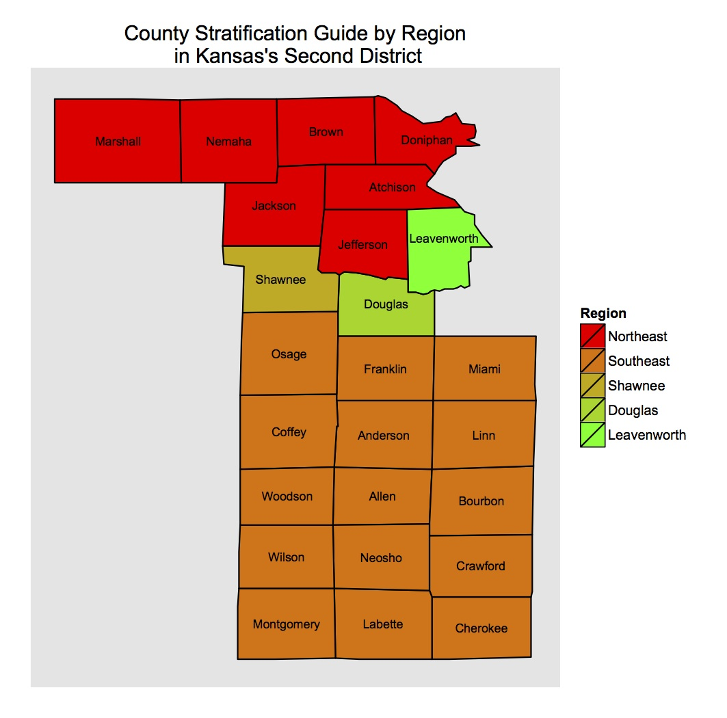

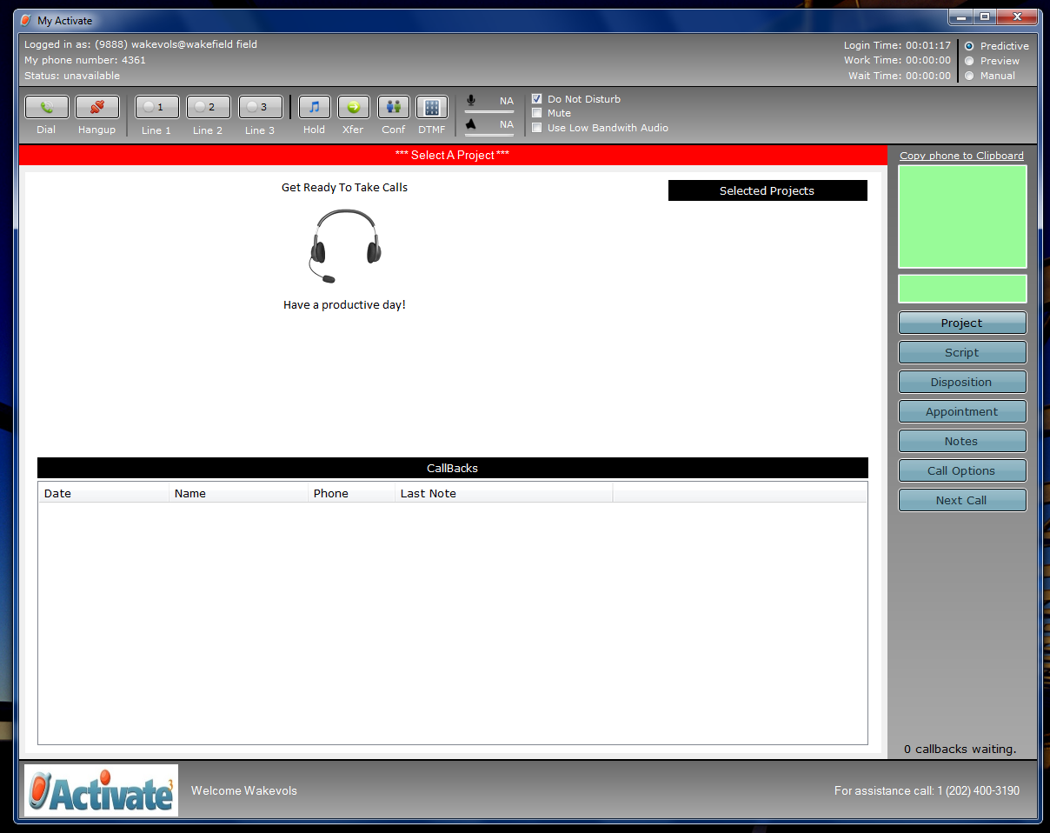
Figure 2: A picture of Activate's predictive dialer, used by volunteers for collecting surveys. The white space in the Screen displays the survey when a voter picks up the phone is dialed, and the software allows volunteers to record responses via menus added to the survey.

Figure 4: Overlaid density plots of the bootstrapped sample predictions. Each of the methods was given a randomly subdivided set of training data, which was used to predict test data. The resulting superimposed plots can be seen below (R Core Team 2014).
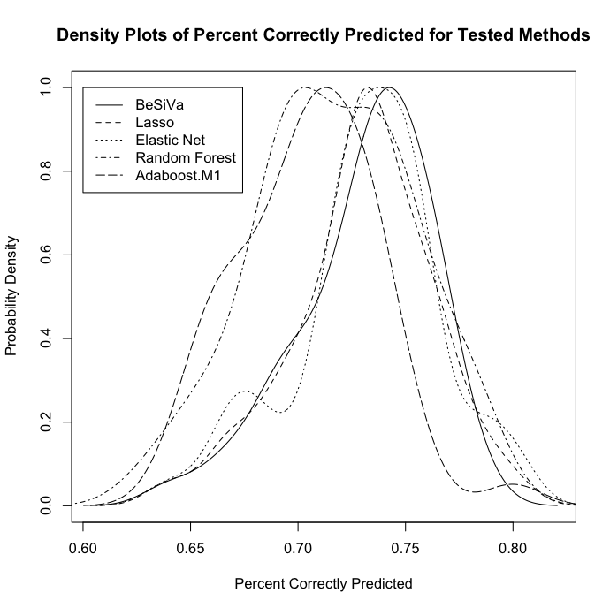
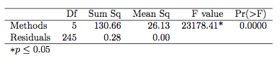
Table 1: Anova Results on the Mean of each method. This table, created using the xtable package (Dahl 2014), displays the result of ANOVA. The F tests has a large enough result that the p value rounds to zero This indicates that the means are different, allowing for the rejection of the Null Hypothesis.

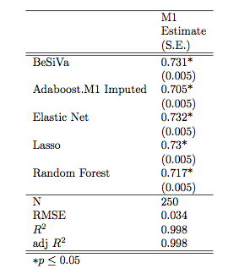
Table 2: A comparison of means. This table, created using the rockchalk package (Johnson 2013), displays the result of the linear regression of the comparison behind ANOVA. While it shows the different means, it appears that the failure of the Null results from the decreased values of Adaboost.M1 and the Random Forest.

How data was collected:
Software for predictive and preview dialing requires three things to make calls: a valid phone number (which people being called must see for legal reasons), a survey or script for survey workers to read when a call is made, and a list of people to call. The list for the calling portion came from a stratified random sample of voters, pre-selected from the full list of voters in the Second District proportionally based on the number of people in five regions of the district based on population and political import. These regions included Leavenworth, Shawnee, Douglas, and Counties in the northeast and southeast sections of the Second District, with the regions pictured in the appendix as Figure 1. I drew this data from a state level voter database curated by the Kansas Democratic party, selecting records based on the proportions of the population in each region. Information on these individuals including name, phone number, and the voter database's identifier of a unique record were loaded into the predictive dialer to allow the voter to be called.
When a volunteer uses Activate's predictive dialer to collect surveys, the software, pictured in the appendix as figure 2, presents an interface which lets the volunteer make calls, starting by selecting a calling project. Once a volunteer selects the project, they uncheck the box labeled 'Do Not Disturb' to start making calls. Unchecking 'Do Not Disturb' causes the predictive dialer to begin calling numbers on land line phones, automatically screening out answering machines, numbers for which service was unavailable, and phones that were allowed to ring but had no answering machine attached. Due to the desire for efficiency in calling, multiple calls are made at once, attempting to find a number of calls that maximizes the amount of time survey workers spend talking to voters, while also preventing too many voters from being called at once. If too many voters are called, then there will be more voters picking up the phone than there are survey workers to take their calls, leading to dropped or abandoned calls, calls where voters are called and hang up before being connected to a volunteer. Once a potential voter picked up the phone, the volunteer saw the survey display in the dialer software, as well as the voter's name and gender for the purpose of verifying identity. Having confirmed the identity of the voter, survey workers read the script, coached specifically to use only the wording that showed up on the screen and not to deviate from it, which was necessary due to their work on persuasive calling projects. The survey workers used drop down boxes included in the script to record each voters' response to a question from a set of options designated by the campaign. For cell phones, the predictive dialer interface did not change, but parts of the interface specific to cell phones were used, altering how the volunteer used the software. To comply with the law, the software called cell phones in preview mode. Using Activate's software in preview mode requires a volunteer to hit Next Call to bring up a voter's record and the survey, and then press the Dial button to call that voter. Pressing Dial causes the software to dial the voter's number, and the volunteer then waits for the voter to answer the call, requiring survey workers to deal with answering machines, unanswered phones, and service problems. After a call had finished in both predictive dialing and preview dialing modes, the volunteer needed to leave a brief summary of how each call went, called a disposition, before moving on. Dispositions allow the campaign staff managing calling to get a better sense of how calls are going, and they direct the software on whether to call a voter's number again. Once a record is dispositioned, the software allows the volunteer to continue calling, either by starting to dial numbers automatically in predictive mode or by hitting Next Call to bring up the next record in preview mode. Once calls were completed, the volunteer checked the Do Not Disturb box again to make themselves unavailable, and exited the program. This software was effective in collecting dependent variable data, the support of voters for a particular position or candidate.

Sample Issue Question:
Lynn Jenkins believes that we need to continue to explore and expand oil, gas and coal to meet our nation's energy needs and strengthen our energy security. She believes that innovations in fracking technology have vastly improved our ability to extract oil and gas and will lead to greater energy independence and jobs. She favors deregulation of fracking, opening national parks to further oil and gas exploration and expansion of pipelines including the Keystone XL pipeline. She does not believe that expansion of alternative energy like wind energy is a viable option to our energy needs.
Margie Wakefield believes that an "all of the above" energy policy is preferable and that we should be promoting investment in a national energy infrastructure to facilitate the rapid growth of the Kansas wind energy industry. During just the past few years, this industry has generated five billion dollars in revenues and over 4,000 high-wage jobs in areas of the state that badly need economic growth. She believes that fracking technology needs to be closely monitored for environmental reasons as well as concern about an alarming increase in the frequency of earthquakes in Northern Oklahoma and South-Central Kansas where fracking has recently increased dramatically.
Knowing that everything is not always black and white and that you might agree with some parts of either statement, can you tell me on a scale of 1 to 10, 1 meaning you agree strongly with Lynn Jenkins position and 10 you agree strongly with Margie Wakefield's position, which statement is closer to your own belief?

Final Identification Question:
Sometimes in a survey like this people change their minds about who they might support. If the election were held today for U. S Congress, can you tell me on a scale of 1 to 10, 1 being more likely to support Lynn Jenkins and 10 being more likely to support Margie Wakefield, who you would be more likely to support?

References
Alfaro, Estefan, Matias Gamez, and Noelia Garcia. 2013. adabag: An R Package for Classification with Boosting and Bagging. Journal of Statistical Software, 54(2), 1-35. http://www.jstatsoft.org/v54/i02/.

Becker, Richard, Allan R. Wilks, Ray Brownrigg, and Thomas P. Minka. 2014. maps: Draw Geographical Maps. R package version 2.3-7. http://CRAN.R-project.org/package=maps

Dahl, David B. 2014. “xtable: Export tables to LaTeX or HTML”. R package version 1.7-3. http://CRAN.R-project.org/package=xtable

Friedman, Jerome, Trevor Hastie, Robert Tibshirani. 2010. Regularization Paths for Generalized Linear Models via Coordinate Descent. Journal of Statistical Software, 33(1), 1-22. URL http://www.jstatsoft.org/v33/i01/.

James, Gareth, Daniela Witten, Trevor Hastie, and Robert Tibshirani. 2013. An Introduction to Statistical Learning with Applications in R. New York: Springer.

Kuhn, Max and Kjell Johnson. 2013. Applied Predictive Modeling. New York: Springer.

Harrell, Frank. 1998. “What are some of the problems with stepwise regression?” May 1998. http://www.stata.com/support/faqs/statistics/stepwise-regression-problems/ (November 10, 2014)

Hastie, Trevor, Robert Tibshirani, and Jerome Friedman. 2009. The Elements Of Statistical Learning: Data Mining, Inference, and Prediction. 2nd ed. New York: Springer.

Johnson, Paul E. 2013. rockchalk: Regression Estimation and Presentation. R package version 1.8.0. http://CRAN.R-project.org/package=rockchalk

Liaw, A. and M. Wiener. 2002. Classification and Regression by randomForest. R News 2(3), 18--22.

R Core Team. 2014. R: A language and environment for statistical computing. R Foundation for Statistical Computing, Vienna, Austria. URL http://www.R-project.org/.

van Buuren, Stef, Karin Groothuis-Oudshoorn. 2011. mice: Multivariate Imputation by Chained Equations in R. Journal of Statistical Software, 45(3), 1-67. http://www.jstatsoft.org/v45/i03/.

Wickham, H. 2009. ggplot2: elegant graphics for data analysis. New York: Springer.

Zou, Hui and Trevor Hastie. 2005. “Regularization and variable selection via the elastic net”
Journal of the Royal Statistical Society B. 67:301–320.

